Democracy; Demosthenian

It’s nothing so monumental; at first
Nothing of grandeur, nothing of burst
Something of seminal, something of seed
Partly subliminal; something we need

When dignity speaks “You and I, we are each
in the image of God and naught can impeach
and nothing intrude, and nothing deface
the reflection of God in the whole human race
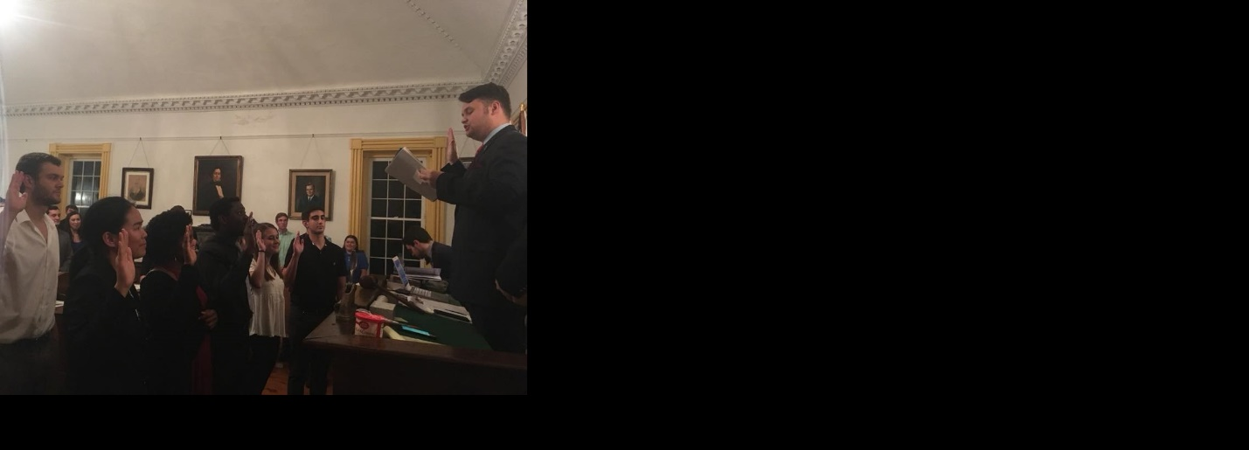

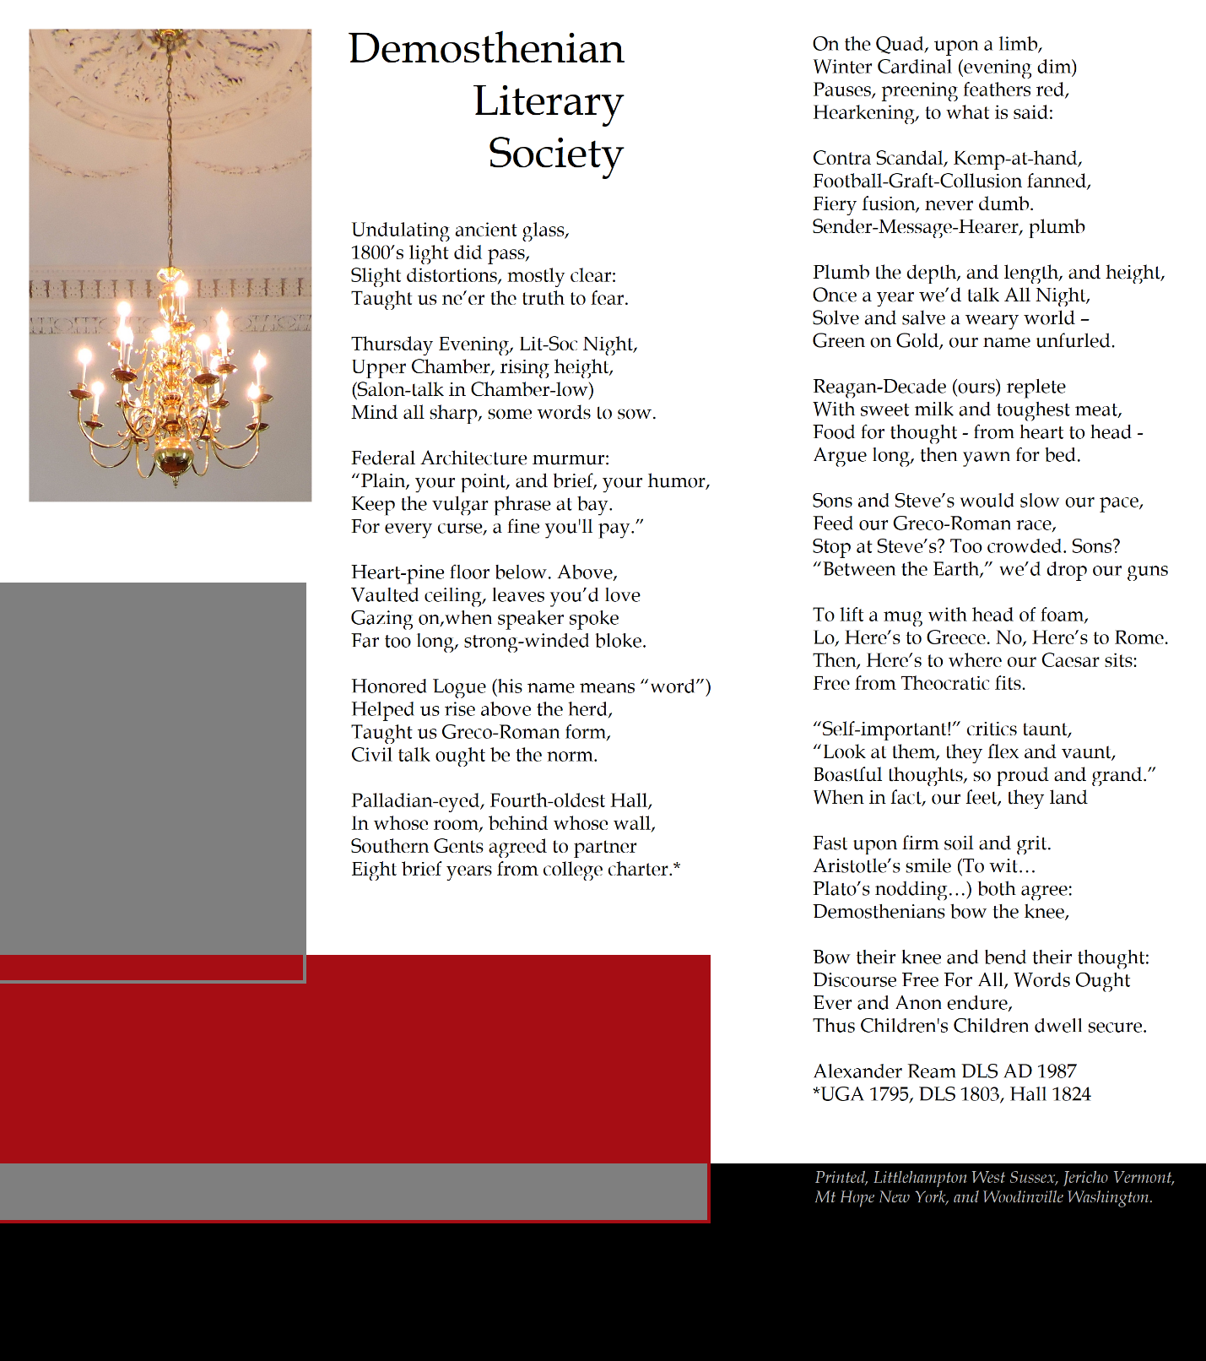

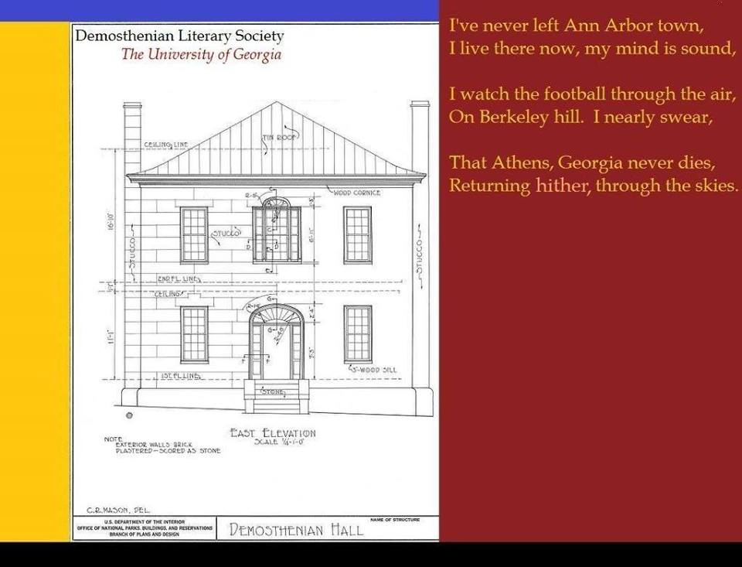

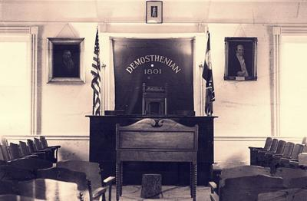
Can’t tell where the time has flown,
Into the great unknown, I guess,
It seems that only yesterday,
I spoke before the DLS,

A chapter colonized - I did,
Alumni twelve, our future hid,
Iraq and Lookout Mountain (write)
I worked for DKE - in sight,

Printed in West Sussex when
I lived at Zeta Zeta then,
In Washington (the state), Vermont,
Mt Hope New York - Times Roman font,

In Arizona’s desert dry,
Writing found, and still was I,
Before a Moonrise, neath a mount,
Unknown would be the printed bount-

-y, in the journal Dickinson,
Emily was printed - stun -
Son of Man and Son of God,
Who cleared the path I finally trod,

So to the farm returning I,
Angus, corn, the cobalt sky:
Reminding me of Berkeley-town,
Ann Arbor, Athens Georgia, down

And upward, circle, spiral spin,
Moving forward, back again,
Is time a circle or a line?
As DNA it’s each entwin-

-ing past and present, future, All
That at the last combines, in Fall

Tabernacle

I know a tribe with blood of blue,
Worn and weathered as a shoe,
I know a tribe with blood of red;
New and vibrant, robust bred.

I asked em both What do you think?
About this Earth - upon the brink –

"Scant we stumbled on this place,
Humble shant, the human race;
Bound in love for God are we,
Because profound He's trod with me
Photo / Steven Dunst

