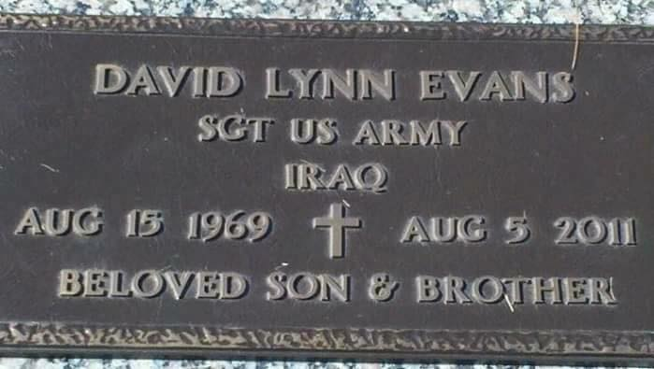
This guy was pissing by my bunk
At 2AM; he dropped the drunk
Evans had this reflex quick
No feckless thought- arithmetic

That’s all I knew of Evans, true
And now he’s dead - but take a cue -
An honor culture sacrifice
Proud and tough and smart and nice

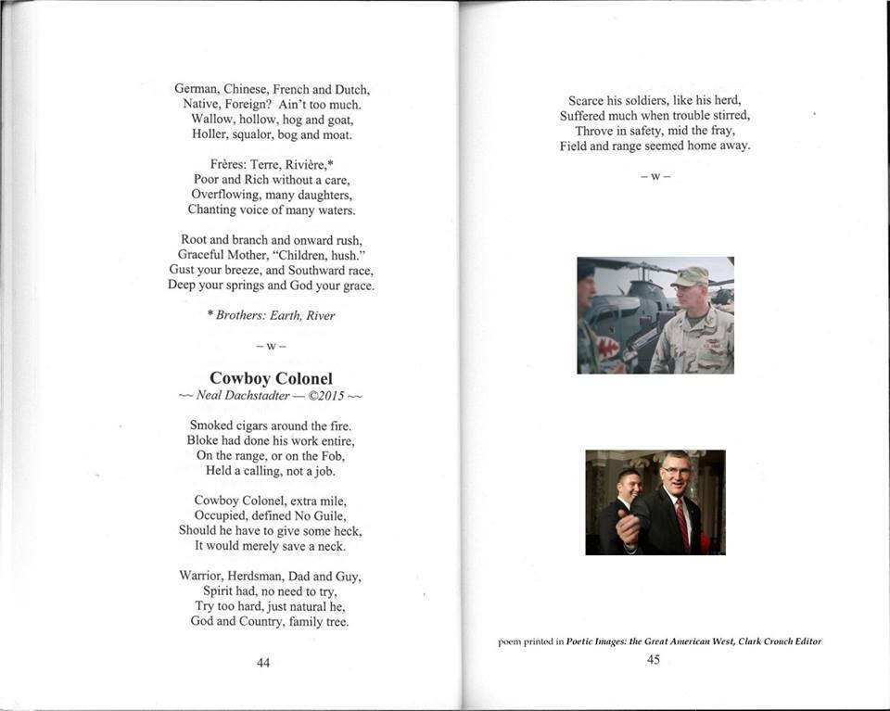

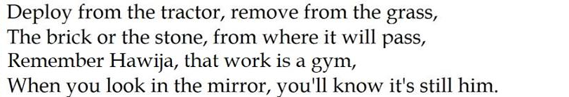

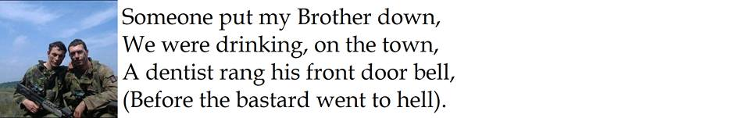

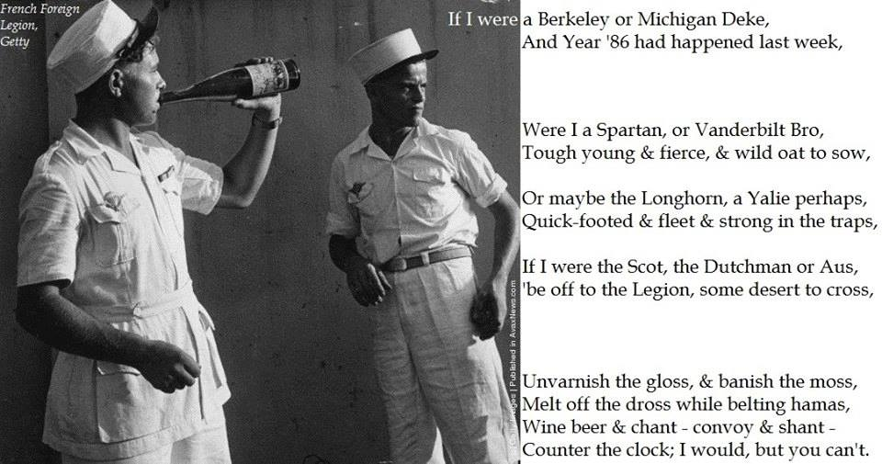

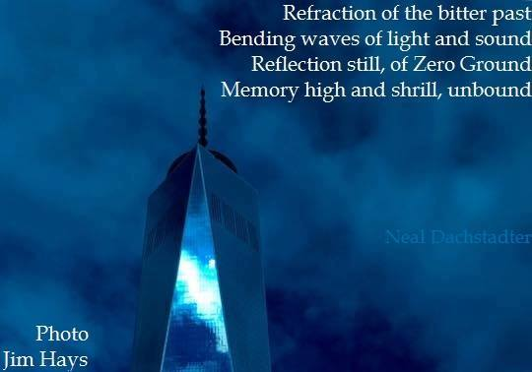

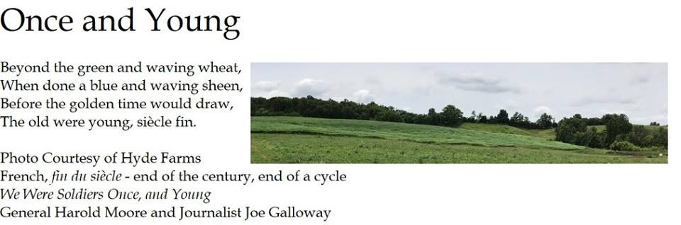

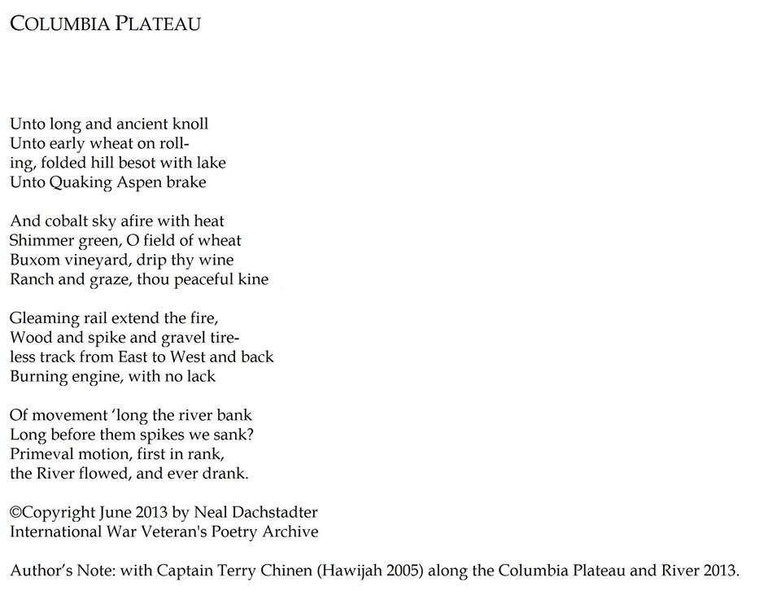

You’d Write
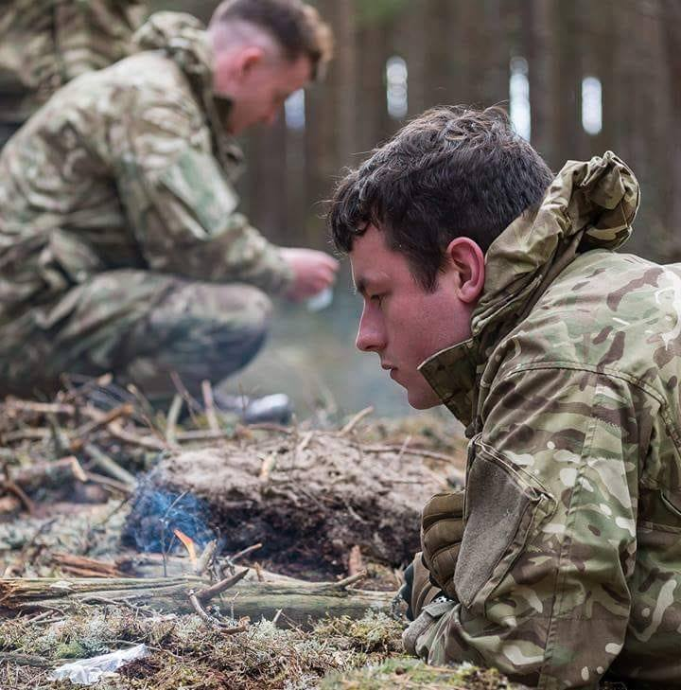
You'd write for the fellows of Army and Deke
In field, and the octagon, yellow’d they speak
not; unheard of the murmur in suffering long
Still spurred onto firmer, discovering strong.
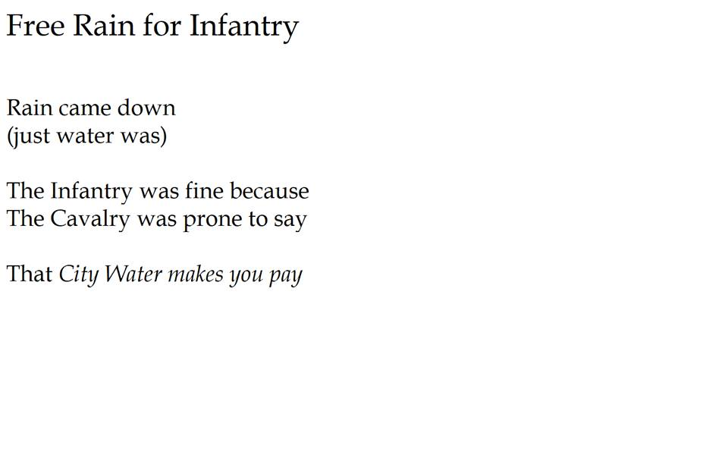
WHERE WERE YOU IN ‘62?

Les Politiciens
“Where were you in ‘62?”
The school alumni deftly ask,
“Reunion… time to pour a brew,
And pop a cork, or drain a cask.

Allow the troubled world to cease.
We’ll dress so fine. To this we’ll feast:
Our time in life when all was new.
Our sky was blue in ‘62.”

La Legion
“Your sky was blue, the desert brown.
Your stock went up, a flag came down.
Diplomas cost diplomacy;
And rendered lost une Algérie.”

The night bright red, le sang: rouge noir
When to the forts men bade bonsoir,
While Charles de Gaulle returned a call
To Jean Paul Sarte, who played his part.

Fey southward under burning skies
Les Anciens ended final ties
And glared a motto toward the sand:
“The Legion is our Fatherland.”

They looked upon the desert towns
Which they (defending, long extending
France’s reach to southern beach)
Once called their own. Tous parfait? Non,

But not so sad as what has bad-
ly long ensued, for 50 crude-
ly squalored years, replete with fears,
And squandered tears, and grinding gears,

And broken glass, and beaten lass
(lo now becloaked beneath her yoke).
Bonne Algérie, a sundered crass
Might trade that freedom. Think me joke?

Were men less free, quand colonies
Bespeckled lands and southern sea?
Were women slaves? Had fled the Jew?
En Algérie, dans Soixante-deux?

Sonnes questions hover in our day.
Bonne Algérie, so lovely? Nay,
No longer beau sans France’s flag,
Lo, stronger? No, askance, does lag.

L’Algérie
“Forsake your pall, O Charles de Gaulle.
Sarte (not Camus) wake your ass to
My cry beneath a darkling sky:
‘Bon Hommes we knew, till ‘62.

One hundred and a third, they stayed,
Until the gentry – merde you played
That with no statecraft, honor flayed,
Slayed: low, beneath my dust now laid,

Where men made walls and towers built
(now blasted, fades a tarnished gilt),
By foe, étranger blood was spilt.
Though Legion bayonets, sans silt,

Were sunk to haft. These proud remain
Unlike your daft legerdemain.
Pardonez-vous while we explain:
Bons Hommes were few, en Soixante-deux.

I heard them tous chant in my gloam,
On golden sand, and crusty loam,
And on the strand, by ocean foam:
‘The Legion is our land, and home.’”

©Copyright 2011 by Neal Dachstadter

BELOW A BRIDGE, ASIDE THE TRACK
Below a bridge, aside the track:
An open tarp, complete with lack
Of all we earn to buy, but save
An Army cot and brick-a-back.

I kept a-pacing toward my lunch
(adept at facing not the punch
of loudly-passing dangerous cars).
Avoid the noise had been my hunch.

To walk at noon was all I meant,
Make firm my fracture – lone intent –
Yet as I walked the tracks today
Said Frugal Sight attention lent.

Beneath the highway overpass:
A man, belongings all en masse,
A-sheltered mid his canvas tent
And (if I would not scorn the Cross),

I thought to self, “Upon return,
I’ll pause amid the noontide burn
And ask if I might sit a spell
And humble-like, his story learn.”

Thus on my journey’s second leg
I left the tracks to pardon beg,
“Excuse me sir, but might I ask,
For strangers’ caps, have you a peg?”

“Sure, have a seat,” he said amid
The smell of roasting meat, to bid
Me have a drink of grapefruit juice
With vodka splash, and so I did.

There’s naught unfitting I could share,
While sitting in his second chair,
We traded talk that most should say
Would qualify for standard fare.

He reads this book of Spanish grammar,
Mine is French, we each did stammer,
Leaving, briefly, common English,
Spanglish, Frenglish, mid the clamor:

Speeding tires above, I-10,
Après-midi (rush hour din),
Broken only when I walked
To buy some orange juice. For when

That grapefruit juice he poured for me?
(to mix with Russian ‘tater-tea)
From humble can, once 1 of 6,
That was his last. So plain to see

©Copyright December 13, 2010 by Neal Dachstadter

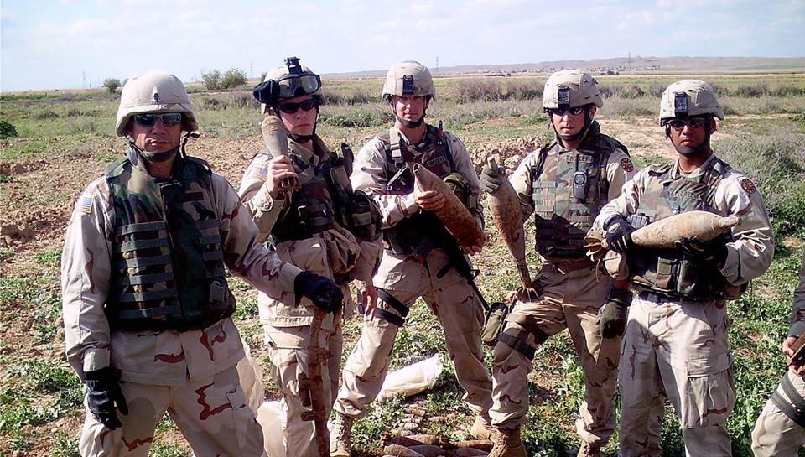
G TROOP OREGON SCOUTS

For Oregon-land, a few of the name,
O’er cobalt Atlantic they flew, each the same,
Not Europe, nor Africa toasted their fame:
But fighting blue Ghost? to Iraq G they came.

AO had been routed to nearby Hawijah
So-heard in a shout, loud and clear when I’d land:
“Chaplain Ream, on Gaines Mill, Ghost’ll likely bad need ya,”
Captain Chinen, with clout: “does that sound like a plan?”

Sergeant Roy he agreed: “we’ll be fine off the KRAB,
Not Spartan, but cloyed do they dine on that slab:
Baskin Robbins ice-cream and fine roast: food for hobbits.
The Air Force? They gleam, most are goodly fat fobbits.”

R Martens was gold, and the sanctified Sergeant.
Boy, Hawijah was bold, ne t-il etais plus l’argent
Vet, this life that you know, you’re still free to be livin?
Bet it’s due to that Joe, plus C-P Terry Chinen.

John Worster, dePaulo, McCauley: mes freres.
Ron played the guitar. The best were all there.
An Episcopal bro, who raced horses back home.
Man the Gemini glow: wherever they roam.

To wit, G was fiercely this non-boring deal.
Shit we scarcely saw more than one vegetable meal.
Unless you include the Galoise cigarettes
At the QRF Shack, when the nicotine hits

Would quick-rapid-fit, then girded you’d be,
Should the Montana 163rd Infantry
(Base McHenry) fast yell for a G-Troop reaction:
Erase some crass, hellish, insurgent freak faction.

At dusk a stout breeze roving cool through the trees
(out running, the olive grove drove you to sneeze)
For the FOB, it had been this grave, rural retreat:
Where whores hob-nobbed Chem and this feral, crazed feat:

in a hood’s room of tile (Ali hosted torture)
Blood staining, guile boasting, no ghost but a monster.
This graced us damn proud: that the first wave had stole
His place and sham grove (fat raving asshole).

Then came the 4th month, within the hard year
On sundown the 5th (it was jarring, too clear)
When G I Joe Kevin, he late did appear.
Unafraid to convey he knew faith, but not fear.

Kevin merely feared God. From a Lutheran youth
Heaven clear was his sod (a sleuth to the truth).
No talk, I just nodded – my words would’ve smeared.
“No balk,” I was prodded, “ungird your good ear.”

So weary – I wanted to stretch and mind sheep,
Slow bleary eye – flaunted my hooch, “time to sleep”
Then conscience me grieved, “Stash every word said.
When freely he leaves? Then crash off to bed.”

Cut non-Pentecostal, Scot-Dutch-French Reformed,
But when I think back, still I blanch, was I warned?
… Kevin Davis your Bro may not see a 3rd morn
Till upward he go, on a Christ shoulder borne…

Not warned in advance. At the time, I knew naught.
But several morns thence, flat sublime, I grew taught:
While “Joe” the Scout spoke, I yawned not, nor stretched.
I kept my pout cloaked, for the Lord He don’t bitch:

A humble kind Friend who is meek, grim and firm
Untroubling the mind seeking Him for a term
Only nodding (no geek) till your finite last word:
Holy Ghost, prodding quiet, du Trinite 3rd

I glean this from Helen, and Donald my grand-
parents’ keen (when I’d visit) their trait was to stand
At their door waving Bye, staring straight, till the car
Was no more (brave to spy, I cared great – from afar).

Vet, fear the true honor, take heed brothers know
They’re tres importante, make no other seed grow.
Should we ever greet Bros…we bless those, “please stay.”
Would me never treat Joes in some lesser way.

A Captain good listens, a Chaplain don’t yawn
Toward luxury food, he won’t bray like a pawn.
Fey soldiers you hear? brave to kill, fit and brawn,
May not see a full year, ‘till a final day’s dawn.

Our Ghost is unfrightened, our Spirit fey-strong
Our host was enlightened, we near it vrai-long
(the most) to be heightened, with Kevin – shui feng,
Where boasts the full day, and full-leavened the song.

“Joe” Davis Vet Kevin, his feast day? 4/8,
No grave met in heaven: Priest Christ his high mate.
Pray for those who did linger, ‘least learned in thy school:
“Yea to shoot me mid-finger, at beast Chemical cruel.”

©Copyright circa 2005 by Neal Dachstadter

O RUSH OF LIFE
Author’s Note: A fraternity brother, Lt. Rob Hornbeck died in military service (Iraq) several years ago. An Elm was planted in the yard of Michigan DKE, Omicron, in memory. Though vandals tried to kill the tree, the broken trunk sprouted the next spring.

~ I ~

The Hornbeck Elm
Had lost its helm:
Some vandals were to blame.

‘Los running by,
He came to spy
The trunk cut down in shame.

“O yes,” I said,
“Will saw it dead.
Who wrought this deed so lame?”

“We shall replace
One in its space,”
Alumnus Len proclaimed.

Mary Catherine cried
And David sighed.
Police – they found no blame.

Till Sarah’s sight:
The Elm alight,
Her trunk was all aflame.

‘Twas glowing green,
Her torch did gleam,
Rob’s message still the same.

“Remember me?
Beyond the sea?
How to Iraq I came?

Then home I flew
To see the crew…
Then fell, but kept my name?

And when I died,
My brethren cried
(I did not seek this fame…

Yet duty called
Me to the hall
Of patriot all the same).”

~ II ~

“Still, sap does flow
Beneath that blow
A vandal did inflict.

You will not die again
But live,
To spite that dreadful nick.

And thus I say
These words this day,
(with weight my voice is thick)

Elm of my rank,
Your wise root sank
Far down into the quick.

The quick is life,
Both joy and strife.
Lo, good and bad afflict.”

~ III ~

“Go Omicron,
Still carry on
Alive, with far more kick.

O be not glum,
O still my chum,
We’ve gotten past that sigh.

When tempted sore
To mind the score
As lost, or simply cry,

Then look for me,
Stand up and see
That twinkle in the eye

Of Freshmen green,
In Rush unseen:
Don’t dare lay down and die.

Be quick to greet
The man you’ll meet.
My bro shall be that guy!

A comrade Green?
Perhaps Marine?
Who guards land, sea and sky?

Or just a man
Who’ll bridge the span
Of Deke, so broad and high?

As broad and high as any Elm,
As limited – stout as any helm
(don’t let the vandals nigh).

Thus life is full
Of push and pull,
The struggle waxes high.

When low you sink,
Pray stop, and think
Of me, and where I lie.

Until I rise
Look toward the skies;
Redemption draweth nigh.”

©Copyright 2013 by Neal Dachstadter

THE MILITARY DEAD
When your soldiers, they all live
But you, in war, find your death
Your military brother, he thinks of you
In the sky blue, and true: “his sort.”

LE MORT MILITAIRE
Quand vos soldats, ils vivent tout
Mais vous, dans guerre, trouvez vos mort
Vos frère militaire, il pense à vous
En le ciel bleu, et vrais: “son sorte.”

©Copyright 2013 by Neal Dachstadter

Author’s note: the French Foreign Legion is my military
Triage

Some battle might be better fought
By some other, with that thought
You have of anger, red and sore
When triage serves the greater war

Cause if you want to kill them, others do too
It's not really special, what you'd like to do

